**¿Cómo crear un proyecto?**

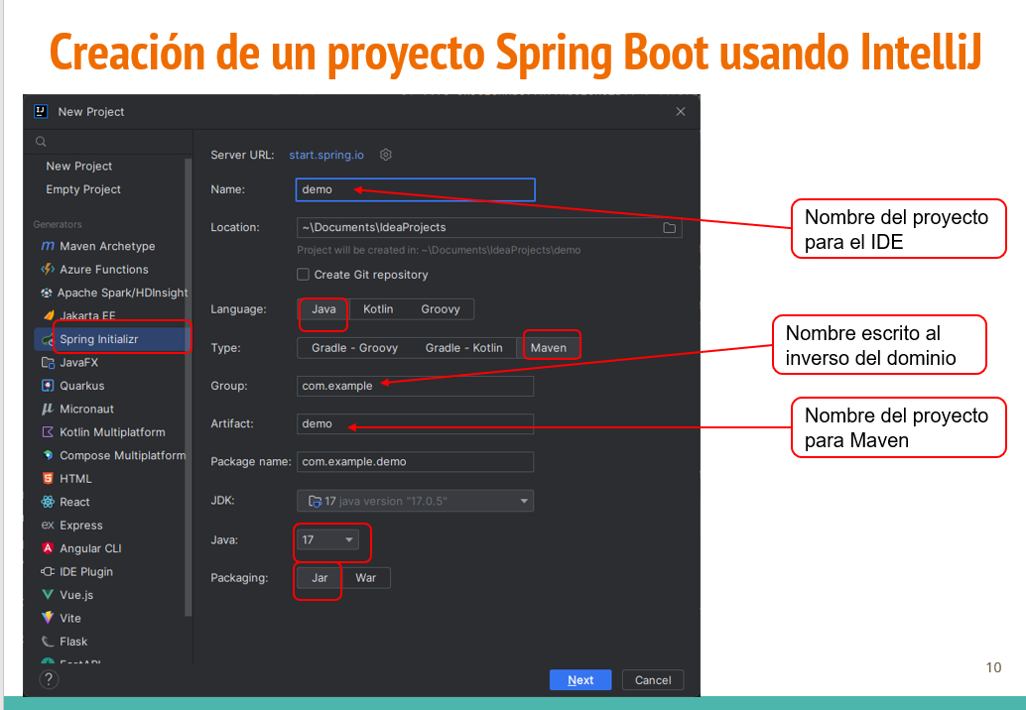

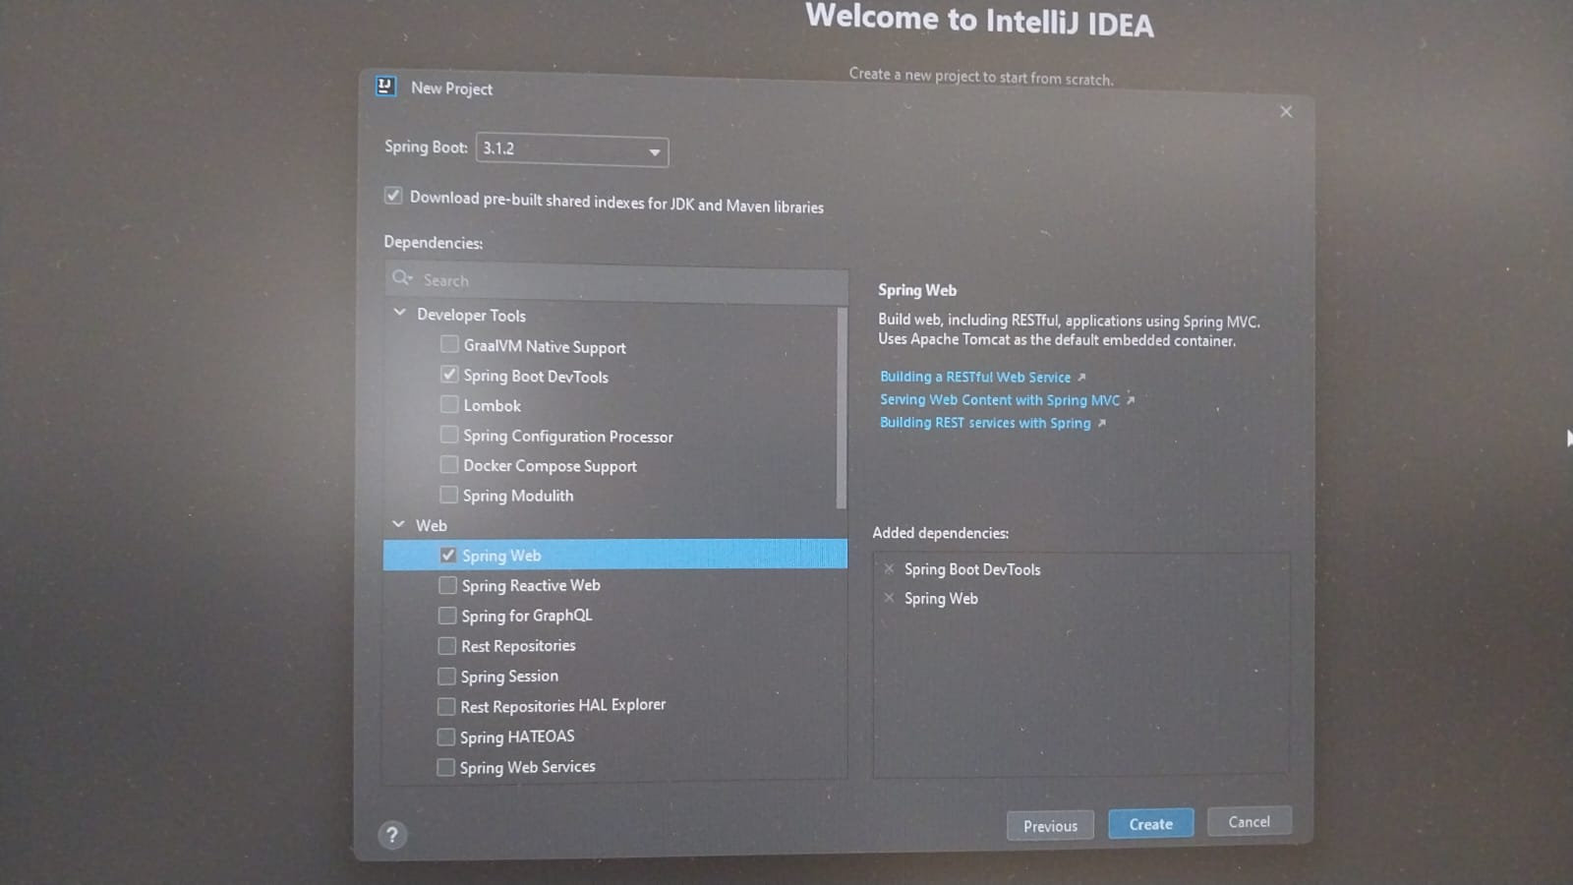

Dependencias:

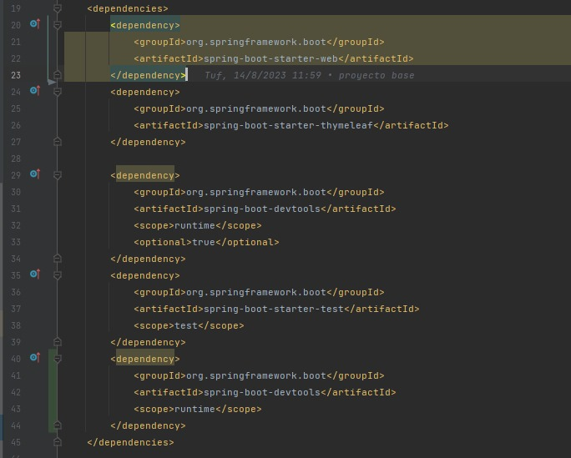

<dependency>

<groupId>org.springframework.boot</groupId>

<artifactId>spring-boot-starter-thymeleaf</artifactId>

</dependency>

<dependency>

<groupId>org.springframework.boot</groupId>

<artifactId>spring-boot-devtools</artifactId>

<scope>runtime</scope>

</dependency>

